PROJECT REPORT TEMPLET

1.Introduction:

1.1.Overview:

A debate is an organized argument or contest of ideas in which the participants discuss a topic from two opposing sides. Those who agree with this statement or idea are the "Pro" side.  Those who will not agree with this statement or idea are the "Con" side.  Each side will show in an organized and clever way why they believe to have the right answers. The aim of a debate is to convince the opposition that you are right. When the two sides agree on the subject or when one side's arguments are more convincing than the other side that is when the debate comes to a close.

1.2.Purpose:

The primary goal of a debate is for students to generate effective critical thinking into primary issues in the given topic. Sample objective statements include:

Through active participation in the debate activity, students will…

* Compare and discriminate between ideas x and y,
* Verify the value of evidence for concept x or y,
* Resolve controversies,
* Recognize strengths and weaknesses of arguments.

2.Problem Definition & Design Thinking:

2.1.Empathy Map:

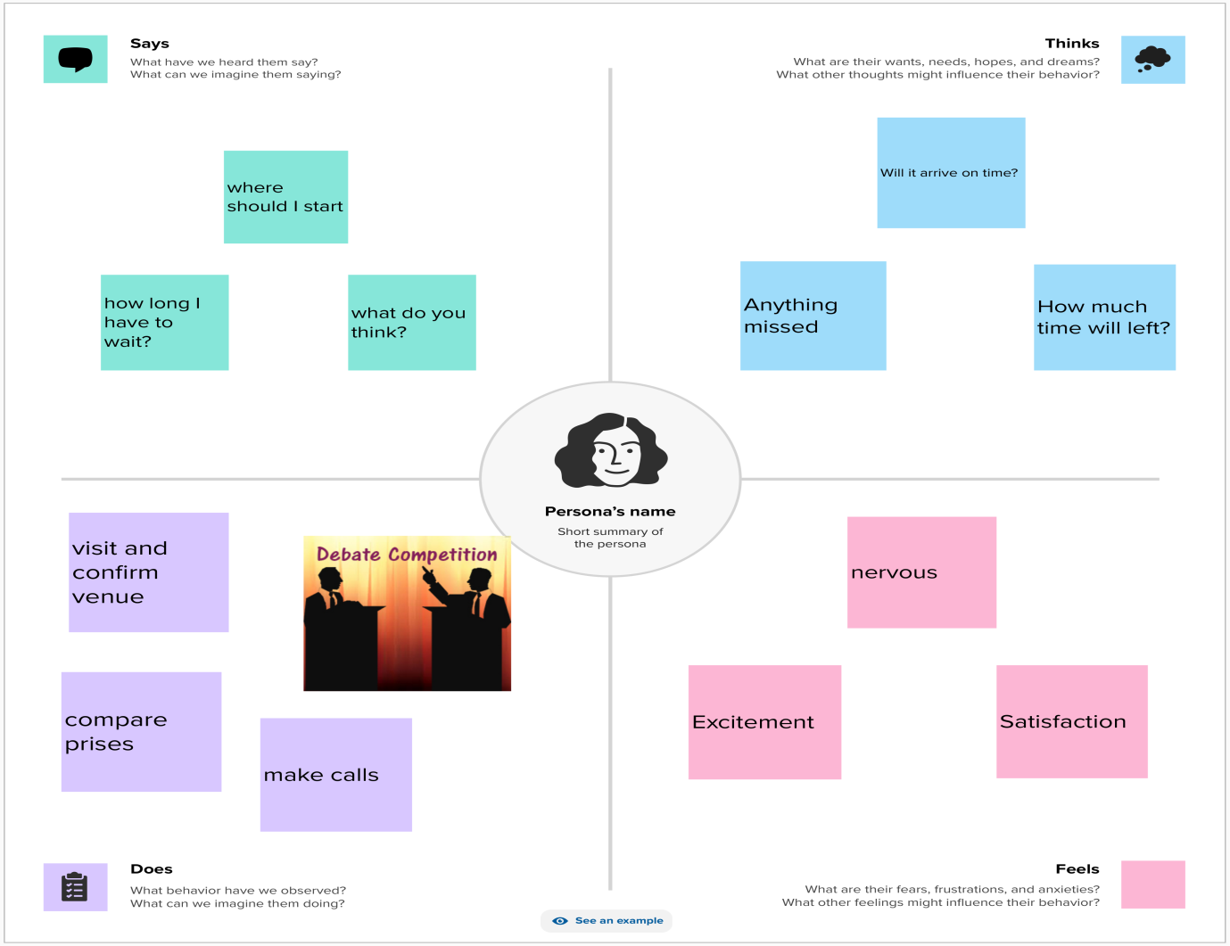

2.2. Ideation & Brainstorming Map:

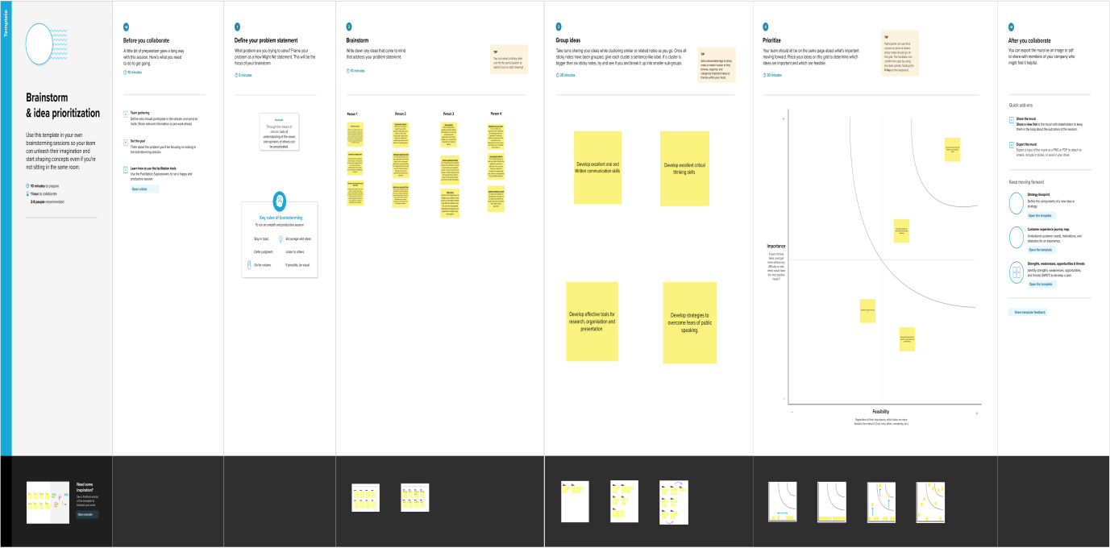

3.Result:

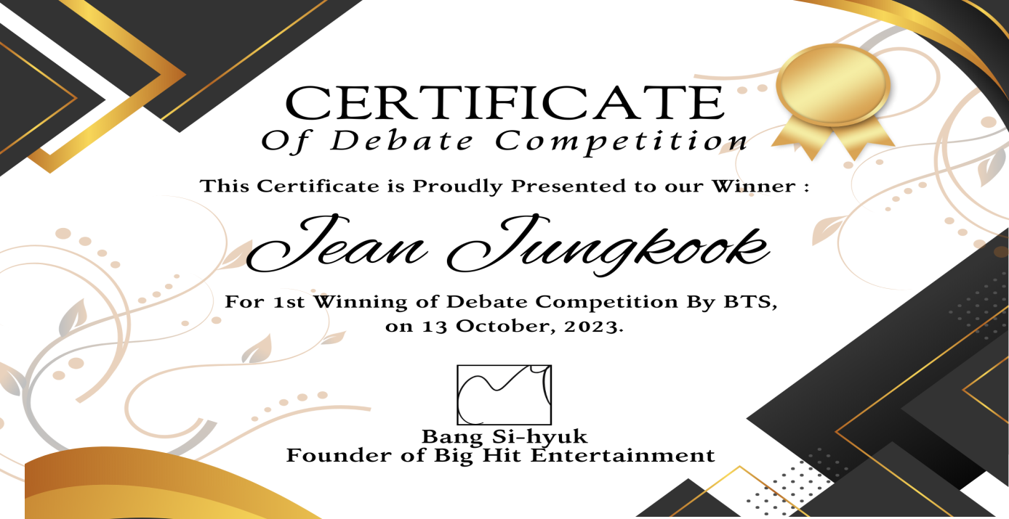

4.Advantages & Disadvantages:

Advantages:

* This reward boosts their morale and encourages them to achieve more in their life.
* Students who get these rewards show them to others to prove their talent and skills.
* promotes problem solving and innovative thinking, and helps students to build links between words and ideas that make concepts more meaningful.
* Develop excellent oral and written communication skills.
* Develop excellent critical thinking skills. Develop effective tools for research, organization and presentation.

Disadvantages:

* Some people think that everything is finished after getting a certificate, that they don’t need to learn anymore, and that they have become the master of the Universe
* Although certification programs provide structured and integrated learning opportunities, we should not forget that each of them has its own perspective on the projects, and they are never neutral.

5.Applications:

It is a type of tangible award that is generally for those people who turn out to be good debaters. These certificates are best to be used in competitions when those who have worked hard are required to be appreciated and encouraged.

6. Conclusion:

"Certificate of conclusion" is a correct and usable part of a sentence in written English. It's often used to refer to a document which certifies that someone has completed a course or other kind of program. For example, "She proudly displayed her certificate of conclusion on the wall of her office."

7. Future Scope:

Scope of Certification refers to the certified product, process, service and/or management system which complies with the certification requirements produced/provided at the sites as granted in the permit/certificate